Assonance Rhyme

🔹 What is Assonance Rhyme
# Source: AI Source: Provided by: [Data Path: Persons Table -> ID Column: 1, Name_En Column: Motasem Essam] -> From: [Chatgpt (GPT-4-turbo)] on [8/1/2025]
(⚠️ Like pararhyme, this is a rhyme type, not a type of homograph—but some homographs can incidentally create assonance rhymes.)

✅ Definition of Assonance Rhyme
# Source: AI Source: Provided by: [Data Path: Persons Table -> ID Column: 1, Name_En Column: Motasem Essam] -> From: [Chatgpt (GPT-4-turbo)] on [8/1/2025]
Assonance rhyme is a poetic device where only the vowel sounds match between words, while consonants differ, especially in final syllables.
🔊 It’s based on sound, not spelling or meaning.

🧪 Structure:
# Source: AI Source: Provided by: [Data Path: Persons Table -> ID Column: 1, Name_En Column: Motasem Essam] -> From: [Chatgpt (GPT-4-turbo)] on [8/1/2025]
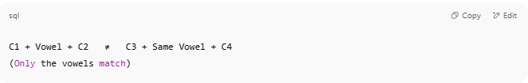
C1 + Vowel + C2 ≠ C3 + Same Vowel + C4
(Only the vowels match)

📝 Examples of Assonance Rhymes
# Source: AI Source: Provided by: [Data Path: Persons Table -> ID Column: 1, Name_En Column: Motasem Essam] -> From: [Chatgpt (GPT-4-turbo)] on [8/1/2025]
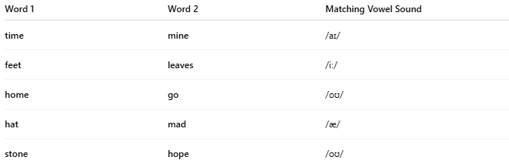
Word 1 | Word 2 | Matching Vowel Sound
time | mine | /aɪ/
feet | leaves | /iː/
home | go | /oʊ/
hat | mad | /æ/
stone | hope | /oʊ/

🧭 How Homographs Relate to Assonance Rhyme
# Source: AI Source: Provided by: [Data Path: Persons Table -> ID Column: 1, Name_En Column: Motasem Essam] -> From: [Chatgpt (GPT-4-turbo)] on [8/1/2025]
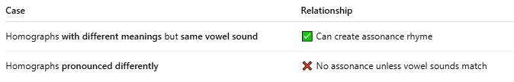
Case | Relationship
Homographs with different meanings but same vowel sound | ✅ Can create assonance rhyme
Homographs pronounced differently | ❌ No assonance unless vowel sounds match

✅ Example (Homograph-Based Assonance)
# Source: AI Source: Provided by: [Data Path: Persons Table -> ID Column: 1, Name_En Column: Motasem Essam] -> From: [Chatgpt (GPT-4-turbo)] on [8/1/2025]
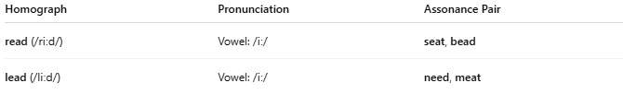
Homograph | Pronunciation | Assonance Pair
read (/riːd/) | Vowel: /iː/ | seat, bead
lead (/liːd/) | Vowel: /iː/ | need, meat

📊 Comparison Table
# Source: AI Source: Provided by: [Data Path: Persons Table -> ID Column: 1, Name_En Column: Motasem Essam] -> From: [Chatgpt (GPT-4-turbo)] on [8/1/2025]
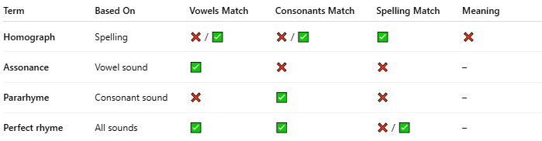
Term | Based On | Vowels Match | Consonants Match | Spelling Match | Meaning
Homograph | Spelling | ❌ / ✅ | ❌ / ✅ | ✅ | ❌
Assonance | Vowel sound | ✅ | ❌ | ❌ | –
Pararhyme | Consonant sound | ❌ | ✅ | ❌ | –
Perfect rhyme | All sounds | ✅ | ✅ | ❌ / ✅ | –

✅ Conclusion
# Source: AI Source: Provided by: [Data Path: Persons Table -> ID Column: 1, Name_En Column: Motasem Essam] -> From: [Chatgpt (GPT-4-turbo)] on [8/1/2025]
- Assonance rhyme is not a type of homograph, but homographs with shared vowel sounds may coincidentally create assonance rhymes.
- It is best classified under types of rhyme (like internal rhyme, slant rhyme).

